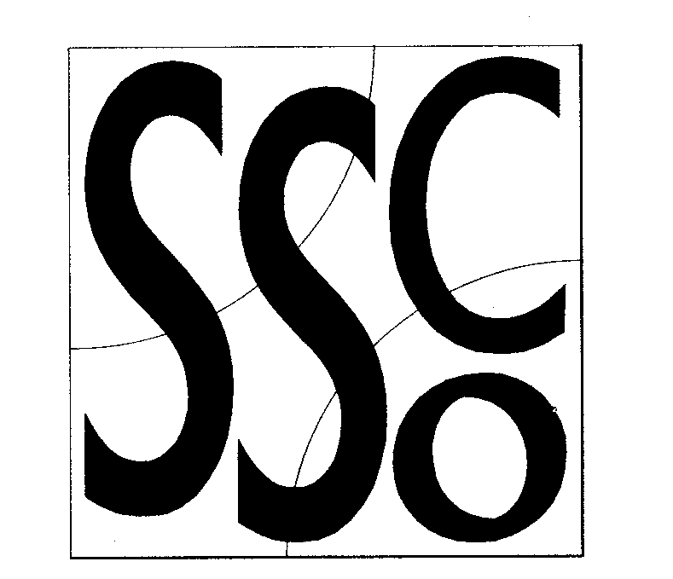

Teaching points.
Ensure pupils are ready to move in a restricted area and have appropriate special awareness.

Video Game
MULTI SKILL CARDS



Classification;
Body Awareness
Equipment:

- Throw down lines to mark out areas
Differentiation
Progressions: restrict the space so that pupils have to be aware of others and dodge out of their way.

To simplify: To make the game easier you could increase the size of the area and indicate the direction of travel to pupils..
Activity key points
Children are spaced around in an area which is clearly marked.
Whilst keeping the head up and looking in the direction of travel, children respond to the following video controls, using the appropriate actions:
Play - walk around
Rewind - run / walk backwards
Fast Forward - run
Pause - jump on the spot
Stop - stop
Eject - Jump Up!
Record – face a partner and imitate each others actions
Standby – pupils sit down and shut their eyes.

